November 16, 2015
City Council, City Manager, City Staff, and Citizens of Destin:
On November 4th, I received a letter from Attorney Dana Matthews on behalf of his client Peter Bos. This letter was an attempt to threaten me into submission. It demands I cease speaking in my capacity as a city councilmember, on behalf of the citizens I have been elected to represent, about unfair, improper and even dangerous conditions perpetrated by Mr. Bos and his representatives. The letter stated they are prepared to seek all legal remedies against me, including compensatory and punitive damages, unless I published letters of retraction within 10 days in both newspapers as well as my own website, and cease and desist any disparaging communications about Mr. Bos or his businesses.
This threat is about an email I wrote within my scope of duties as a councilmember to our city manager, Greg Kisela, in August. The email detailed concerns about the public’s ability to use the Osteen public beach access and safely swim in the water there. It was made public as part of a public records request by a citizen and published on August 25th, in its entirety, on social media.
Let me state for the record: I will not be bullied or threatened into not performing my public duties. I won’t be bullied or threatened into shirking my job as a councilmember- not by Mr. Bos, Mr. Matthews or anyone. As they have now threatened to move our differences into the courts if I do not meet their demands, I find I must retain counsel. Since the City retains insurance coverage for such instances, I am requesting the City notify our carrier and request coverage.
It is unfortunate that Mr. Bos and Mr. Matthews have chosen to take this path but, for all of us on the dais, it is vital that we- as elected representatives of the people of Destin- are not bullied into nonsense lawsuits. We should engage in and encourage open, honest dialog without threat, even if we disagree.
I was elected to serve in good faith and speak to the needs, wants and concerns of those who live and work here and whom voted for me to be their voice. I have a duty to do what’s right by them and will continue to do so- not just because it is my duty, but because it’s the right thing to do.
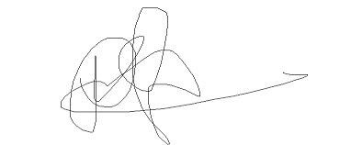
For Destin,

Prebble Q Ramswell

